Blueberry Bottom Farm – Brighton Iowa – Kim Andersen
kim@blueberrybottomfarm.com

Planting and Care of Day Neutral Strawberries (our method)
Strawberries like a spot with full sun, but can also do well with some shade. They do not love too much water, or they become mushy.
Planting Instructions:
- Plant 12 inches apart in a row. Our rows are also 12 inches apart. Rows are staggered…like your footsteps. Keep 3 – 4 feet between rows or room to walk. We have smaller aisles and that is why we do not offer U-pick for our strawberries.
- Strawberries – bare roots should be planted as soon as possible and kept refrigerated until they can be planted.
- Roots need to go straight down and not be bent. All roots must be covered with soil. We use a strawberry planting tool from Nourse, but you can use your garden trowel. The base of the crown should be at the same level as the soil surface.
- Tamp down the soil around the plant with your hands.
- Water immediately after planting.
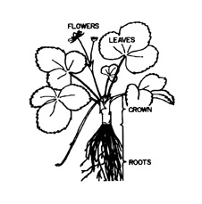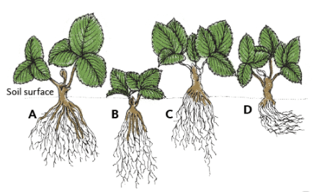
Parts of Strawberry Plant Proper planting depth (A)…and improper depths (B, C, D). In B, the crow is too deep; in C, the crown is too high; in D, the roots are bent and remain near the surface.

Care of Day Neutral Strawberries:
- Remove the first set of flowers (we do not do this).
- We grow in holes we burned in white on black landscape fabric.
- Keep weeded, especially early when the plants are small.
- Cut runners. Runners are not needed and will take energy away from fruit production. Most day neutrals are grown as annuals (re-planted each year).
- We use moisture meters to know when to water…but typically one or two times per week for 20 – 30 minutes. We are growing in tunnels so we can control the water. Strawberries like 1 inch of rain per week. Use a soaker hose or let the water trickle.
- We fertigate through our drip irrigation. We use Chilean nitrate for nitrogen and other micronutrients about every 2 weeks during the growing season along with some 5-4-5 that we put down and work into the soil a few weeks before planting.
- Day neutrals will produce from about 4 weeks after planting in the spring, well into the fall. Our last picking in 2024 was November 15. We plan to pull the plants mid-October moving forward so we can get a cover crop established.
- Day neutrals will slow down flowering and production during hot spells, think about when the nights are just miserable without air conditioning. Nighttime temps seem to affect them more than daytime high temps.
- Pick fully ripe berries – red from the calyx or cap to the tip. When picking avoid squeezing the berry or fingerprinting it. Snap the stem instead. The quicker you get the berries cooled down, the longer the shelf life.

